German Alphabet (with basic text translations)

Alphabet:

* Uppercase

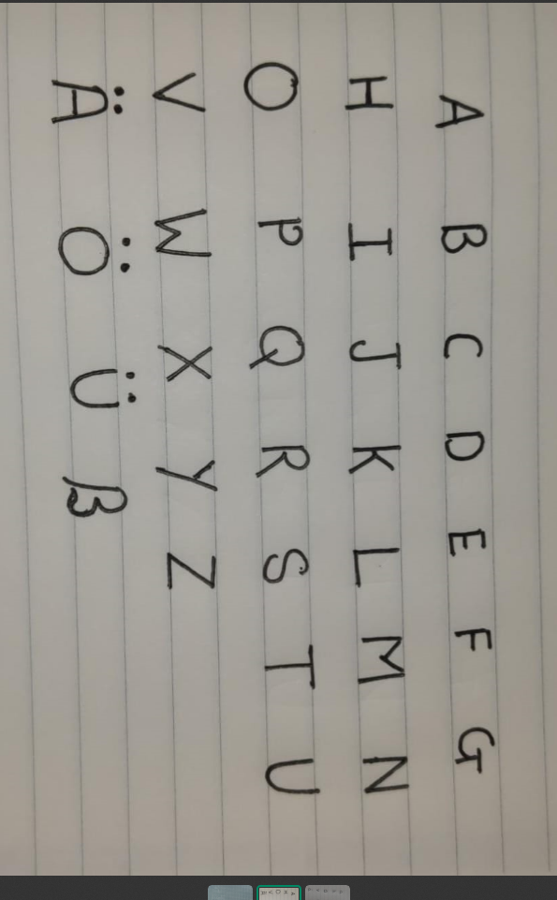

* Lowercase

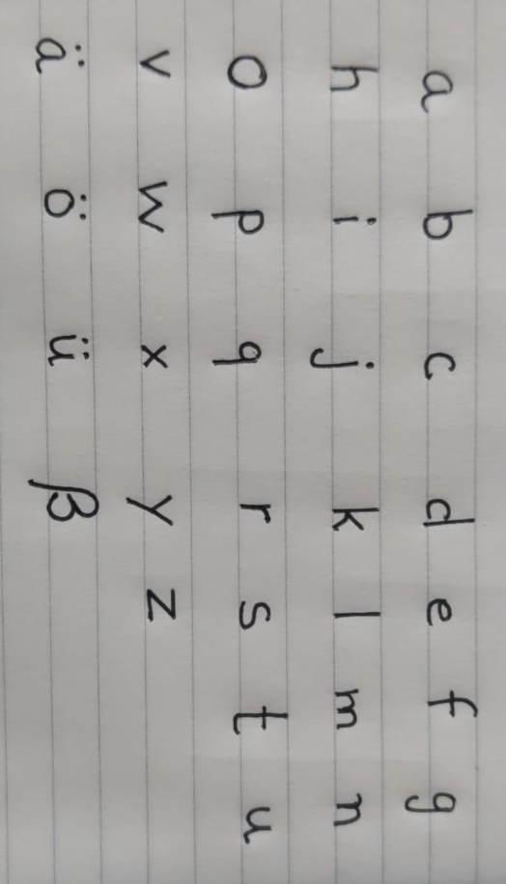

Basic Text Translations:

1. **Good morning, how may I help you?**

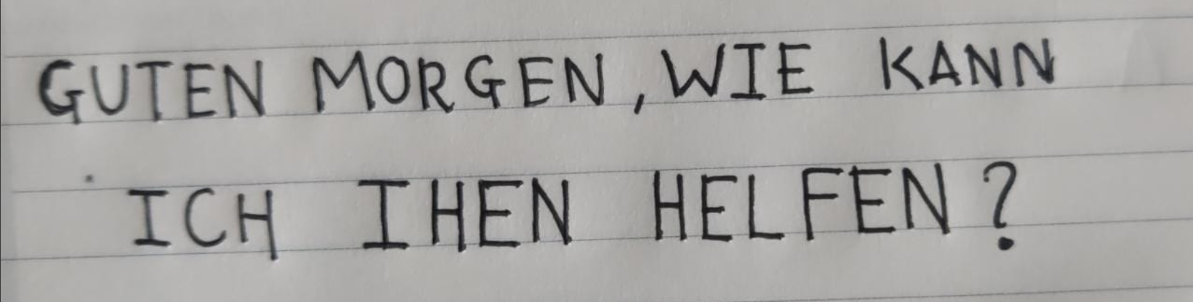

1. **Excuse me, I do not understand.**

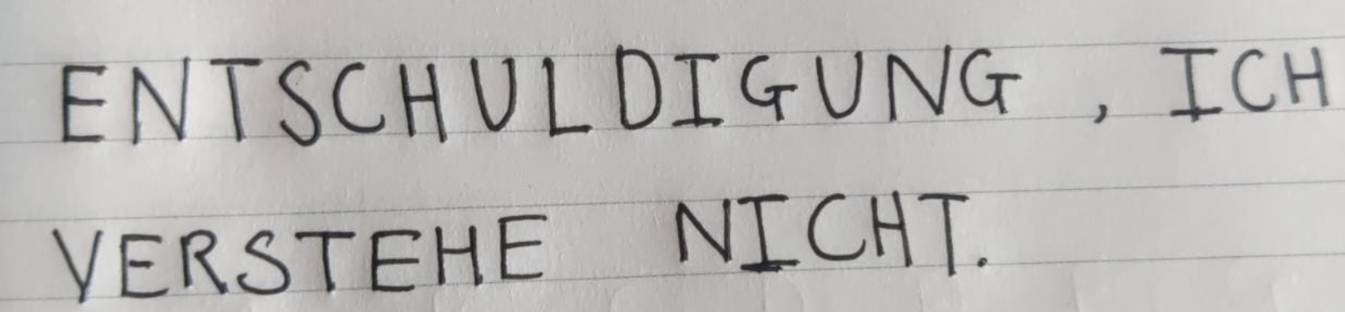

1. **I am lost, please, can you help me?**

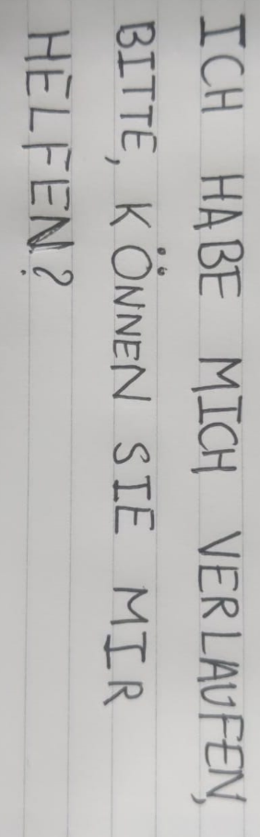

1. **Happy birthday! Have a good day.**

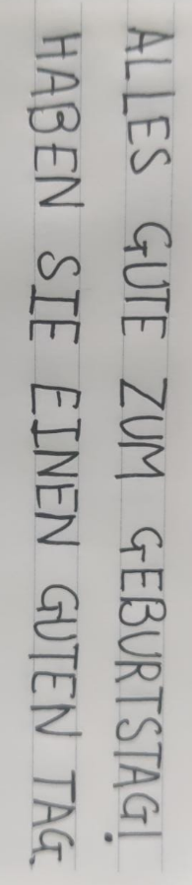

1. **I like going to the museum. What do you like to do?**

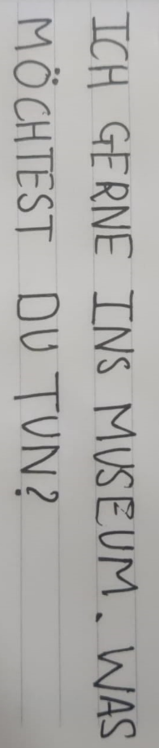

1. **I am sorry, I am not interested.**

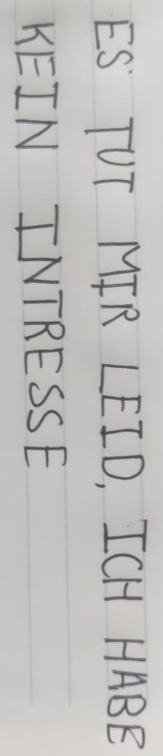

1. **Congratulations! You deserved it.**

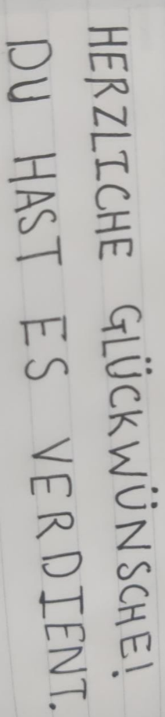

1. **I do not know but take care.**

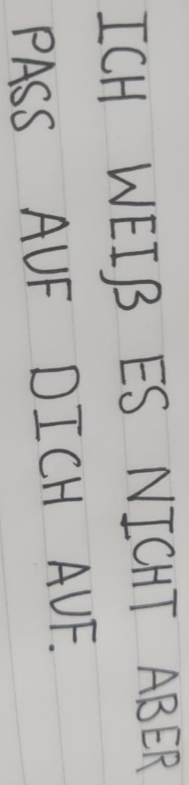

1. **Goodnight, I will see you tomorrow morning.**

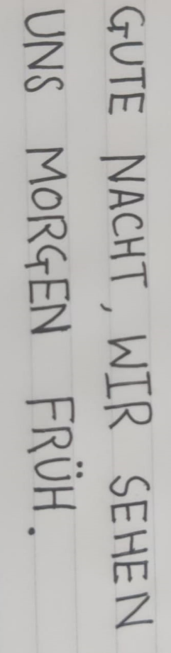

1. **What is your name?**

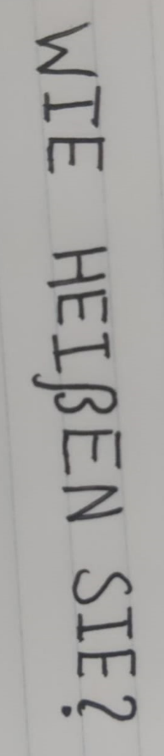

1. **How old are you?**

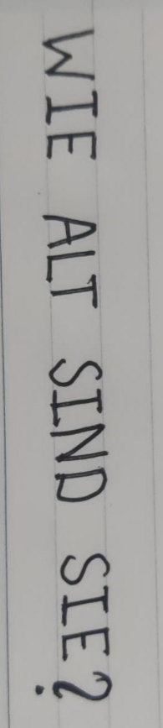

1. **This was fun, I will see you soon.**

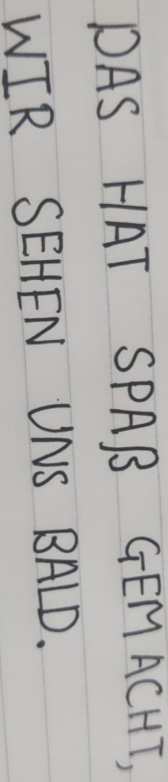

1. **I am sorry, I could not quite catch that, can you repeat again?**

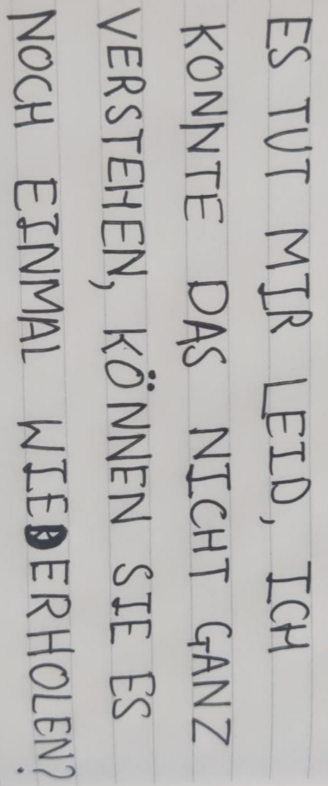

1. **Do not worry, it will be alright.**

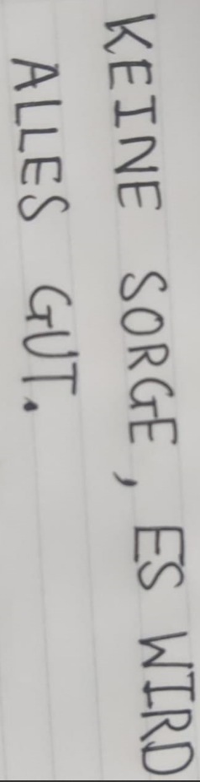

1. **I love cats, how can someone not love cats?**

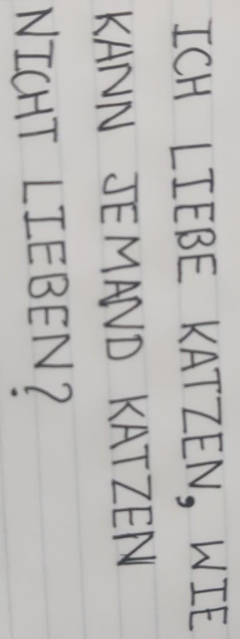

1. **I can see trees. I really enjoy the nature.**

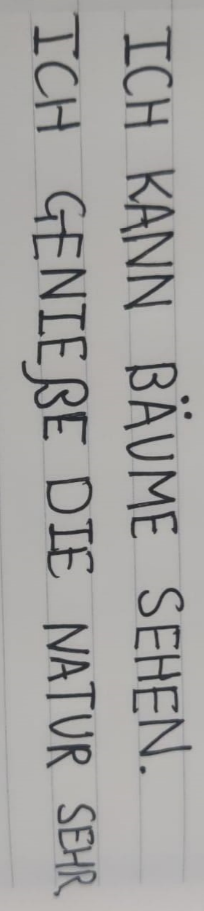

1. **I want to be stress free, what else could one ask for?**

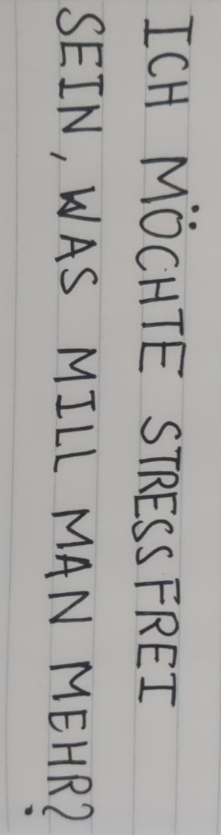

1. **I must go, I will see you next time.**

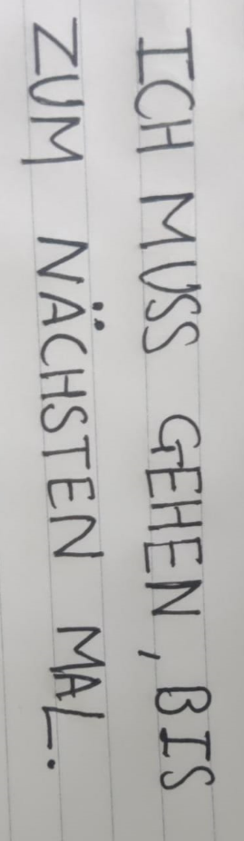

1. **I adore science, it tells us so much.**

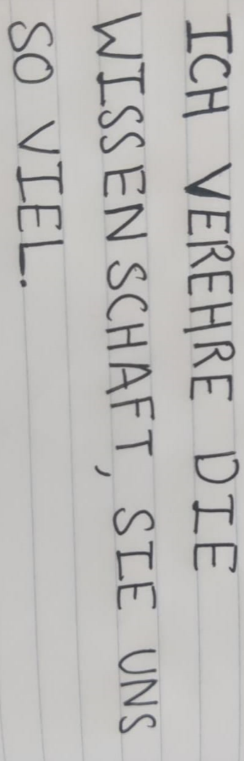

1. **The girl picked the pink flower out of her garden.**

